**ENTITY RELATIONSHIP DIAGRAMS**

**LAB SHEET NUMBER 04**

1)

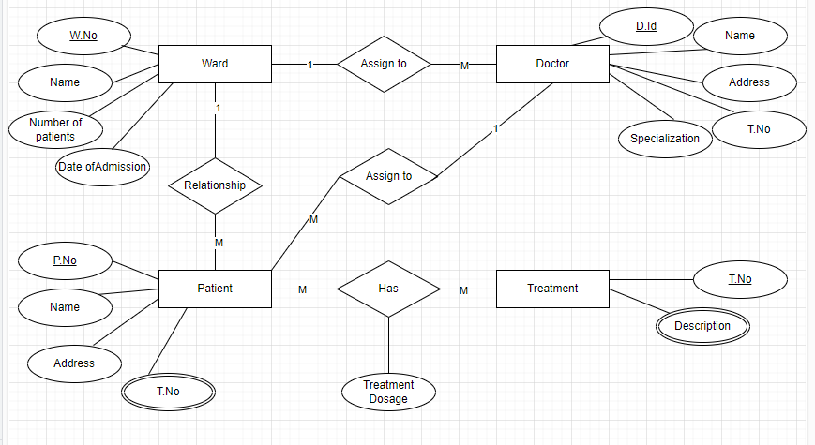

2)

